Shortest path First algorithm (Dijkstra’s)

Given a graph and a source vertex in the graph, find shortest paths from source to all vertices in the given graph.

Dijkstra’s algorithm is very similar to [Prim’s algorithm for minimum spanning tree](https://www.geeksforgeeks.org/prims-minimum-spanning-tree-mst-greedy-algo-5/). Like Prim’s MST, we generate a*SPT (shortest path tree)* with given source as root. We maintain two sets, one set contains vertices included in shortest path tree, and other set includes vertices not yet included in shortest path tree. At every step of the algorithm, we find a vertex which is in the other set (set of not yet included) and has a minimum distance from the source.

Below are the detailed steps used in Dijkstra’s algorithm to find the shortest path from a single source vertex to all other vertices in the given graph.  
Algorithm  
**1)** Create a set *sptSet* (shortest path tree set) that keeps track of vertices included in shortest path tree, i.e., whose minimum distance from source is calculated and finalized. Initially, this set is empty.  
**2)** Assign a distance value to all vertices in the input graph. Initialize all distance values as INFINITE. Assign distance value as 0 for the source vertex so that it is picked first.  
**3)** While *sptSet* doesn’t include all vertices  
….**a)** Pick a vertex u which is not there in *sptSet* and has minimum distance value.  
….**b)** Include u to *sptSet*.  
….**c)** Update distance value of all adjacent vertices of u. To update the distance values, iterate through all adjacent vertices. For every adjacent vertex v, if sum of distance value of u (from source) and weight of edge u-v, is less than the distance value of v, then update the distance value of v.

[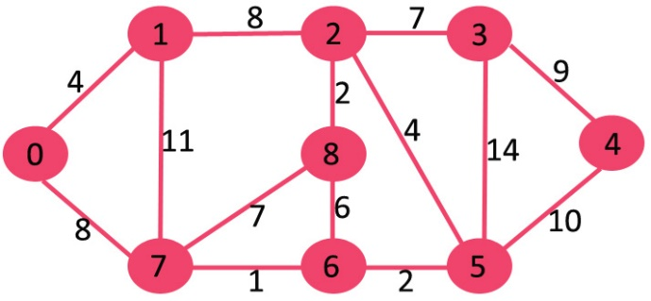](https://www.geeksforgeeks.org/wp-content/uploads/Fig-11.jpg)

The set *sptSet* is initially empty and distances assigned to vertices are {0, INF, INF, INF, INF, INF, INF, INF} where INF indicates infinite. Now pick the vertex with minimum distance value. The vertex 0 is picked, include it in *sptSet*. So *sptSet*becomes {0}. After including 0 to *sptSet*, update distance values of its adjacent vertices. Adjacent vertices of 0 are 1 and 7. The distance values of 1 and 7 are updated as 4 and 8. Following subgraph shows vertices and their distance values, only the vertices with finite distance values are shown. The vertices included in SPT are shown in green colour.

[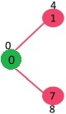](https://www.geeksforgeeks.org/wp-content/uploads/MST1.jpg)

Pick the vertex with minimum distance value and not already included in SPT (not in sptSET). The vertex 1 is picked and added to sptSet. So sptSet now becomes {0, 1}. Update the distance values of adjacent vertices of 1. The distance value of vertex 2 becomes 12.

[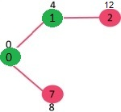](https://www.geeksforgeeks.org/wp-content/uploads/DIJ2.jpg)

Pick the vertex with minimum distance value and not already included in SPT (not in sptSET). Vertex 7 is picked. So sptSet now becomes {0, 1, 7}. Update the distance values of adjacent vertices of 7. The distance value of vertex 6 and 8 becomes finite (15 and 9 respectively).  
[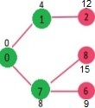](https://www.geeksforgeeks.org/wp-content/uploads/DIJ3.jpg)

Pick the vertex with minimum distance value and not already included in SPT (not in sptSET). Vertex 6 is picked. So sptSet now becomes {0, 1, 7, 6}. Update the distance values of adjacent vertices of 6. The distance value of vertex 5 and 8 are updated.

[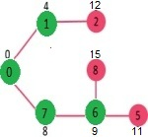](https://www.geeksforgeeks.org/wp-content/uploads/DIJ4.jpg)

We repeat the above steps until *sptSet*does include all vertices of given graph. Finally, we get the following Shortest Path Tree (SPT).

[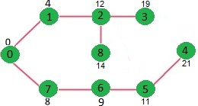](https://www.geeksforgeeks.org/wp-content/uploads/DIJ5.jpg)

**Implementation**

import java.util.*;

import java.lang.*;

import java.io.*;

class ShortestPath {

static final int V = 9;

int minDistance(int dist[], Boolean sptSet[])

{

// Initialize min value

int min = Integer.MAX_VALUE, min_index = -1;

for (int v = 0; v < V; v++)

if (sptSet[v] == false && dist[v] <= min) {

min = dist[v];

min_index = v;

}

return min_index;

}

void printSolution(int dist[])

{

System.out.println("Vertex \t\t Distance from Source");

for (int i = 0; i < V; i++)

System.out.println(i + " \t\t " + dist[i]);

}

void dijkstra(int graph[][], int src)

{

int dist[] = new int[V]; // The output array. dist[i] will hold

// the shortest distance from src to i

// sptSet[i] will true if vertex i is included in shortest

// path tree or shortest distance from src to i is finalized

Boolean sptSet[] = new Boolean[V];

// Initialize all distances as INFINITE and stpSet[] as false

for (int i = 0; i < V; i++) {

dist[i] = Integer.MAX_VALUE;

sptSet[i] = false;

}

dist[src] = 0;

for (int count = 0; count < V - 1; count++) {

// Pick the minimum distance vertex from the set of vertices

// not yet processed. u is always equal to src in first

// iteration.

int u = minDistance(dist, sptSet);

sptSet[u] = true;

for (int v = 0; v < V; v++)

if (!sptSet[v] && graph[u][v] != 0 && dist[u] != Integer.MAX_VALUE && dist[u] + graph[u][v] < dist[v])

dist[v] = dist[u] + graph[u][v];

}

printSolution(dist);

}

public static void main(String[] args)

{

/* Let us create the example graph discussed above */

int graph[][] = new int[][] { { 0, 4, 0, 0, 0, 0, 0, 8, 0 },

{ 4, 0, 8, 0, 0, 0, 0, 11, 0 },

{ 0, 8, 0, 7, 0, 4, 0, 0, 2 },

{ 0, 0, 7, 0, 9, 14, 0, 0, 0 },

{ 0, 0, 0, 9, 0, 10, 0, 0, 0 },

{ 0, 0, 4, 14, 10, 0, 2, 0, 0 },

{ 0, 0, 0, 0, 0, 2, 0, 1, 6 },

{ 8, 11, 0, 0, 0, 0, 1, 0, 7 },

{ 0, 0, 2, 0, 0, 0, 6, 7, 0 } };

ShortestPath t = new ShortestPath();

t.dijkstra(graph, 0);

}

}